Hayley Locke
Clerk
Economic Development, Science and Innovation Committee
Parliament Buildings, Wellington
Hayley.Locke@parliament.govt.nz
26 November 2018
Dear Hayley
PRODUCTIVITY COMMISSION 2017/18 ANNUAL REVIEW
Please find attached the Commission’s response to the Economic Development, Science & Innovation Committee’s written questions. Attached are a number of other supporting documents to support our answers and these are itemised below. You will note, also, that we have included URLs within answers to provide additional information as appropriate.
We have provided answers for all 112 questions. Where meaningful comparative statistics or data exists across financial years we have provided this information for the Committee. In some cases (particularly human resource-related questions) such information does not exist or in our case such comparisons are not meaningful given our small size and that we spent the first five-six years after establishment building our structure and recruiting to an appropriate staffing level.
I confirm that at this point the witnesses attending the annual review hearing on 29 November 2018 at 11.30am will include myself and members of the Commission’s leadership team – Steven Bailey (Inquiry Director), Judy Kavanagh (Inquiry Director), Dr Patrick Nolan (Economics & Research Director), and Daiman Smith (General Manager). We will advise you prior to the hearing if any other Commission representatives will attend and look forward to discussing our performance with the Committee.
Yours sincerely

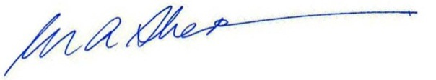
Murray Sherwin
Chair
Copied: by email: EconomicDevelopment.Science.Innovation@parliament.govt.nz

Attached:
- New Zealand Productivity Commission, 2017/18 Review – Economic Development, Science & Innovation Committee Pre-Hearing Questions 1-112
- New Zealand Productivity Commission – Gifts and Hospitality Register (for Question 42)
- New Zealand Productivity Commission – Table of Consultants & Contractors (for Question 68)

